**R Code for Examples in the book**

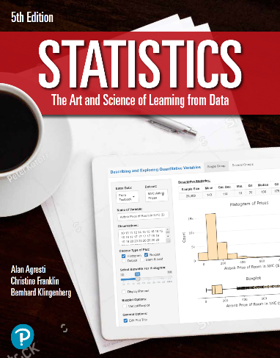

***“Statistics: The Art and Science of Learning from Data”***

**by Agresti, Franklin and Klingenberg, 5th edition**

**Chapter 6**

**Example 5: Risk Taking – Standard Deviation of a Probability Distribution**

## Reading in the data for the sure strategy

gainsSure <- 500  
probsSure <- 1

## To compute the variance

varianceSure <- sum(((gainsSure - mean(gainsSure)) ** 2) * probsSure)  
varianceSure

## [1] 0

## To compute the standard deviation

sqrt(varianceSure)

## [1] 0

## Reading in the data for the risk-taking strategy

gainsRisk <- c(0, 1000)  
probsRisk <- c(0.5, 0.5)

## To compute the variance

varianceRisk <- sum(((gainsRisk - mean(gainsRisk)) ** 2) * probsRisk)  
varianceRisk

## [1] 250000

## To compute the standard deviation

sqrt(varianceRisk)

## [1] 500